**Bonrix**  **Restaurant Software**

1. **Admin management, Account Management, POS, KOT, Captain Management.**

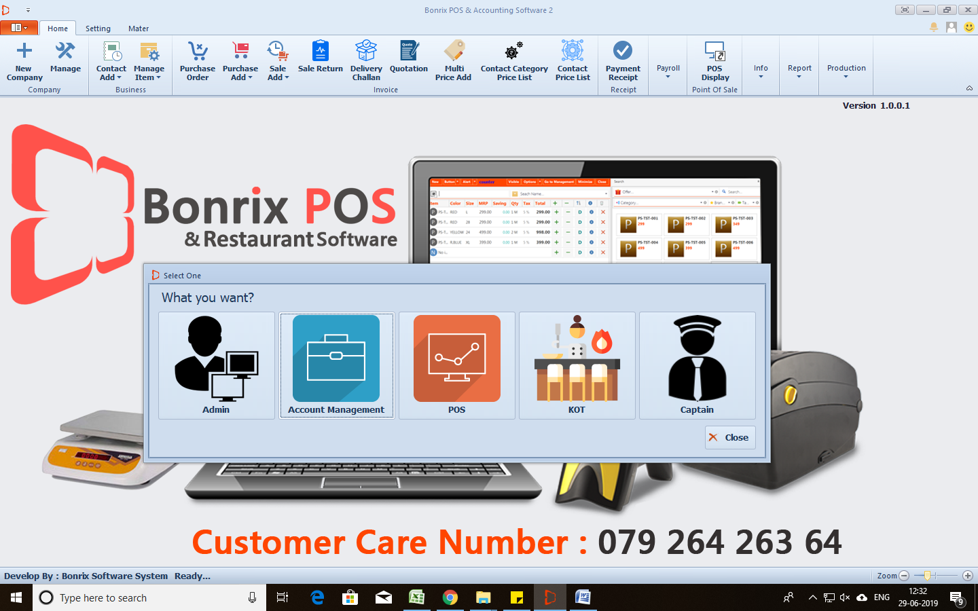

1. **Admin Panel Login Page:**

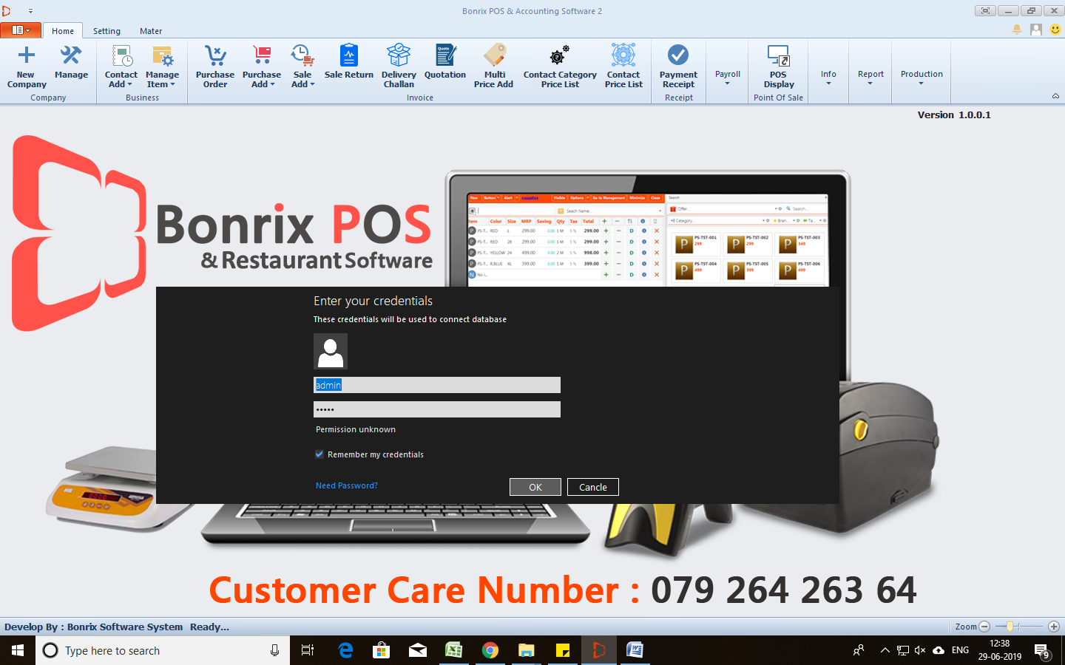

1. **Admin panel > Company Profile Page:**

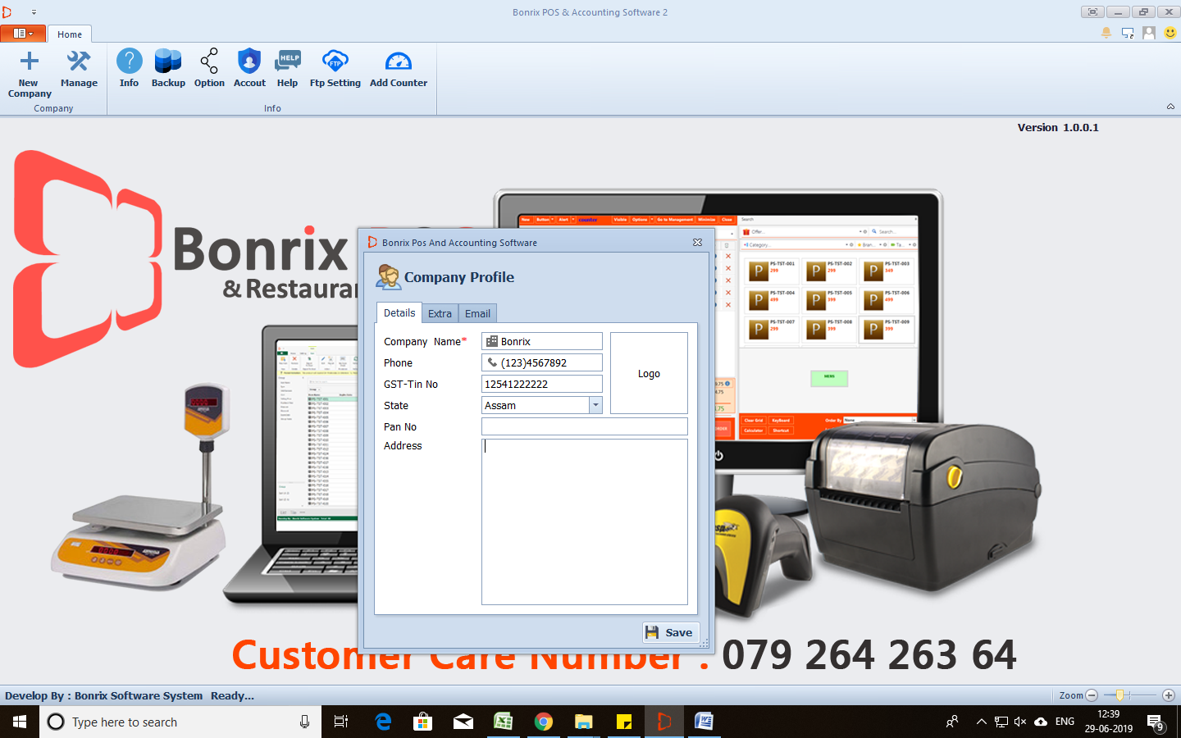

1. **Account management Panel:**

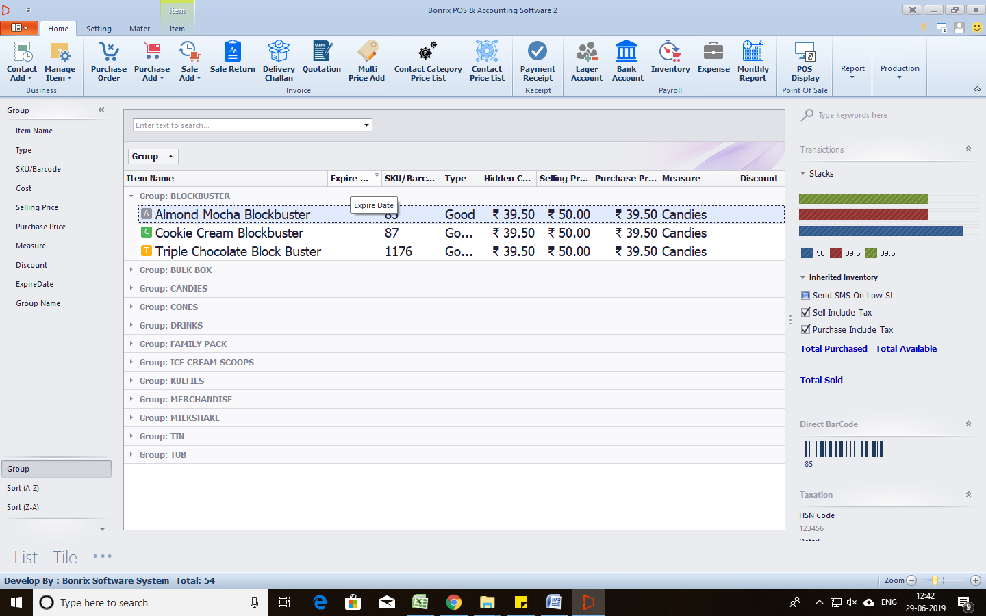

* **Different types of Reports and Inventory Management :**
* 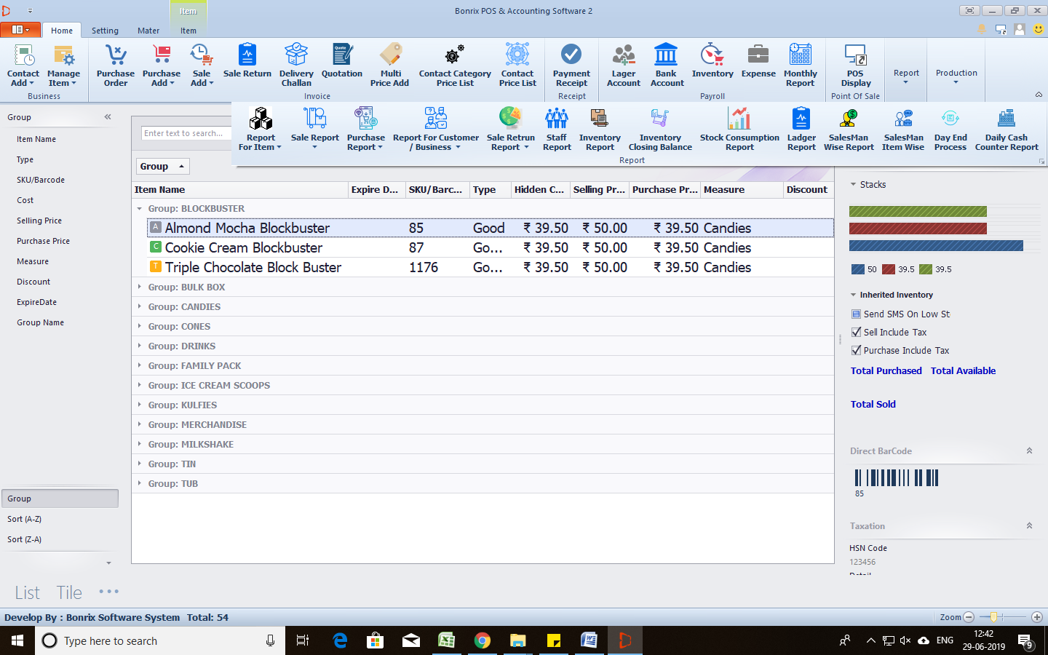

1. **POS Panel:**

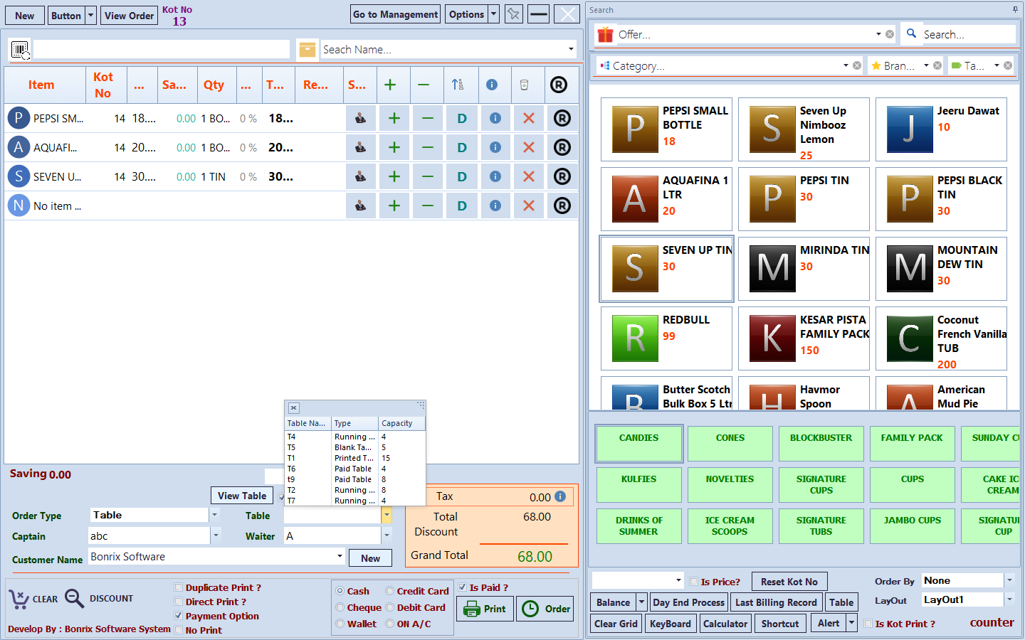

**View Order:**

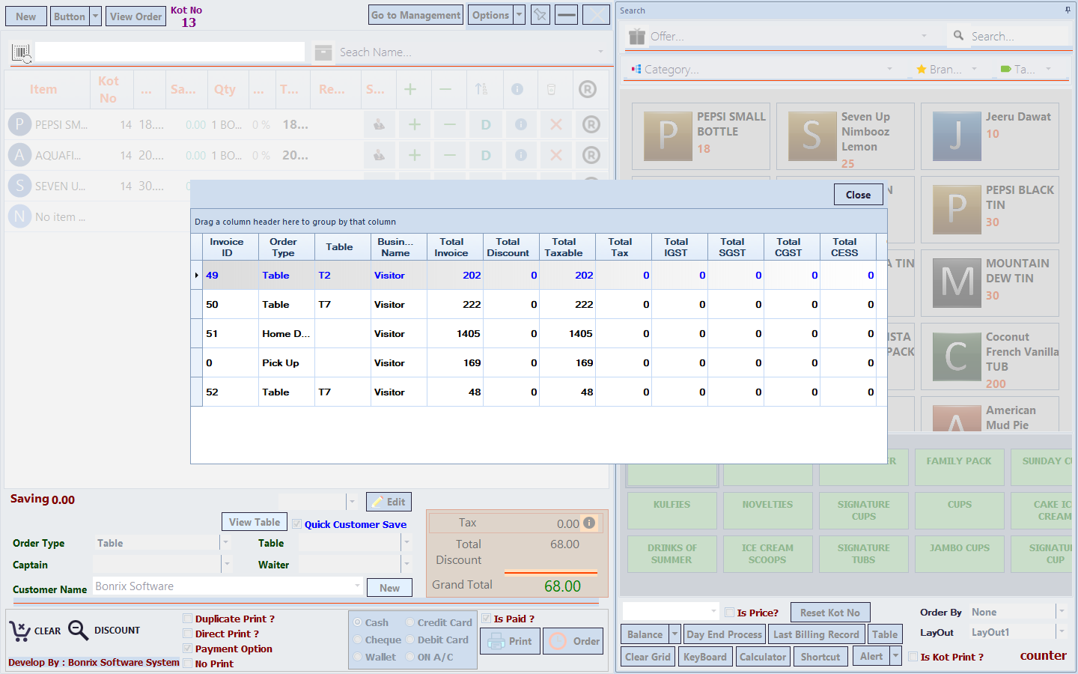

1. **KOT Panel: Kitchen Order Tickets**

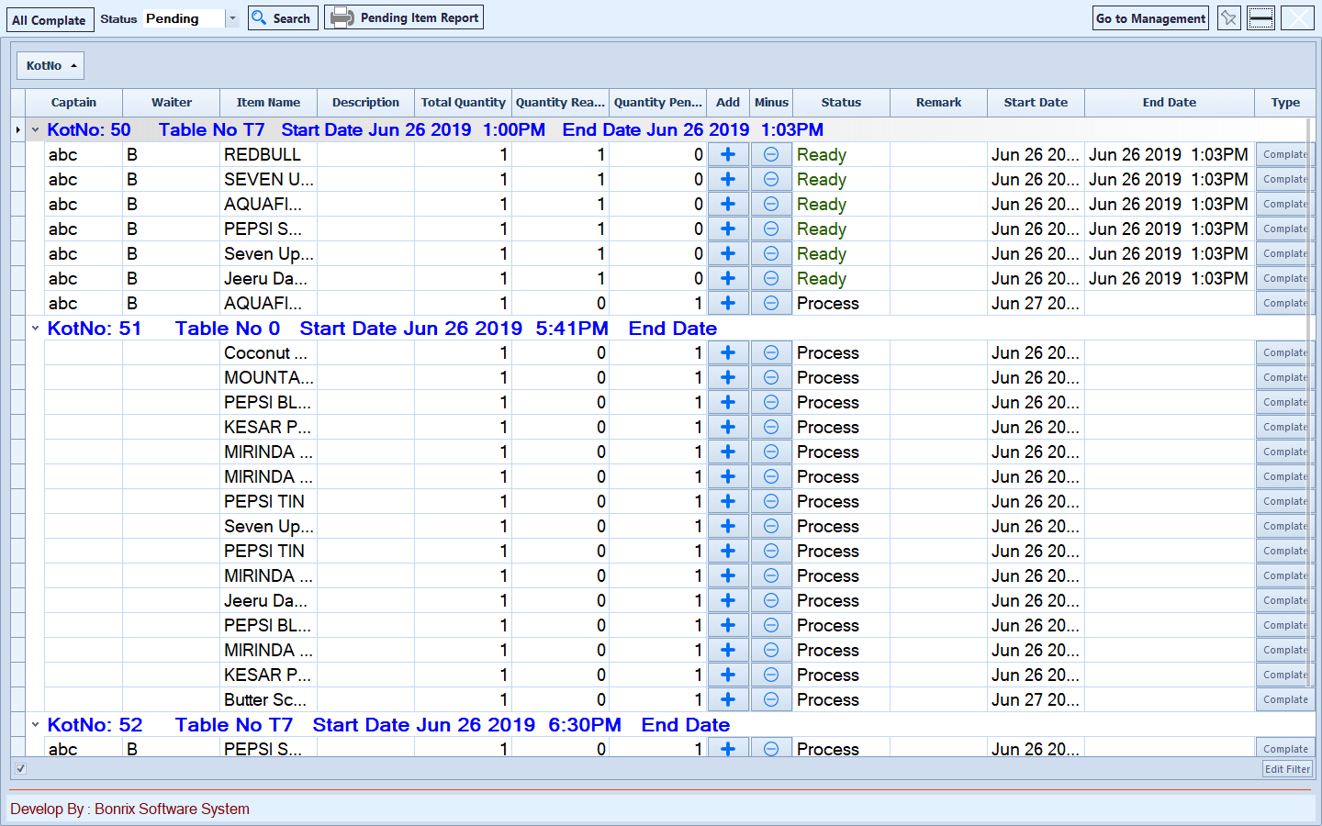

**Pending Items List:**

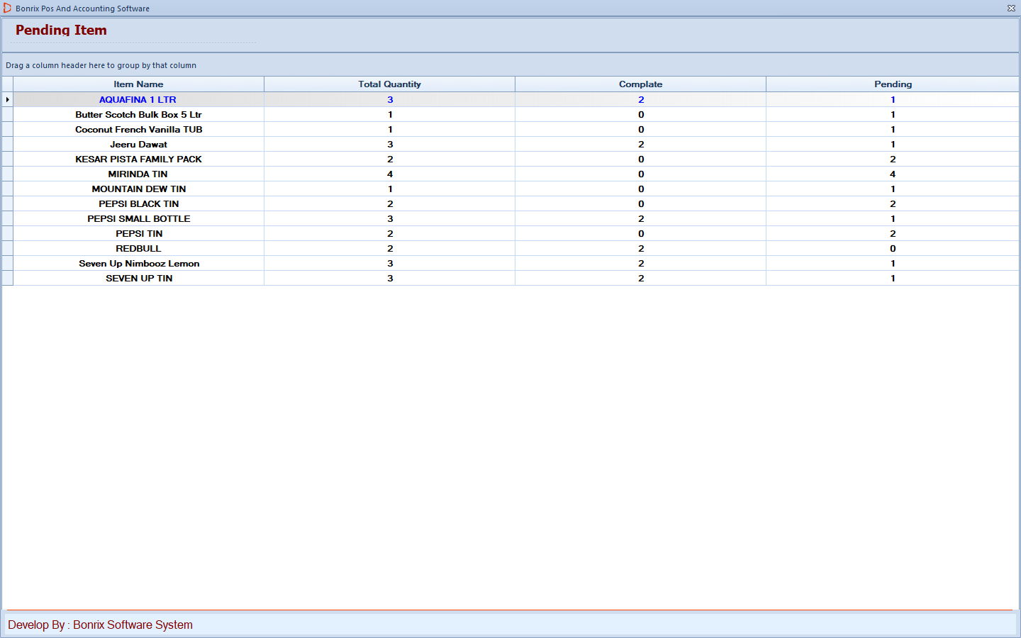

1. **Captain Panel: You can use in Android Machine, Tablet**

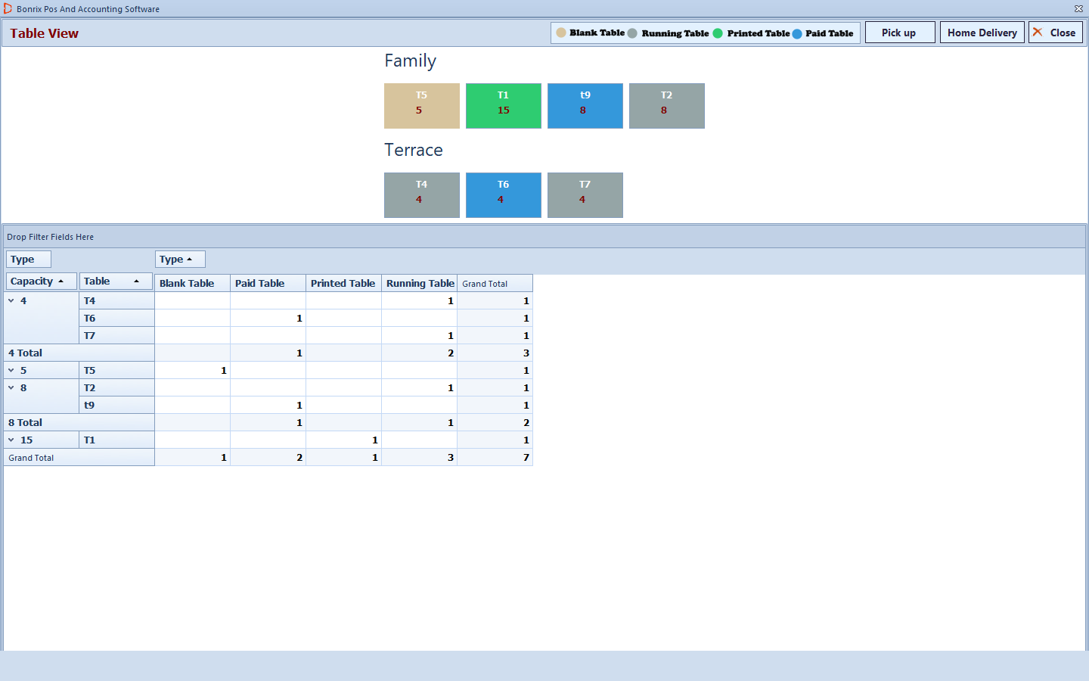

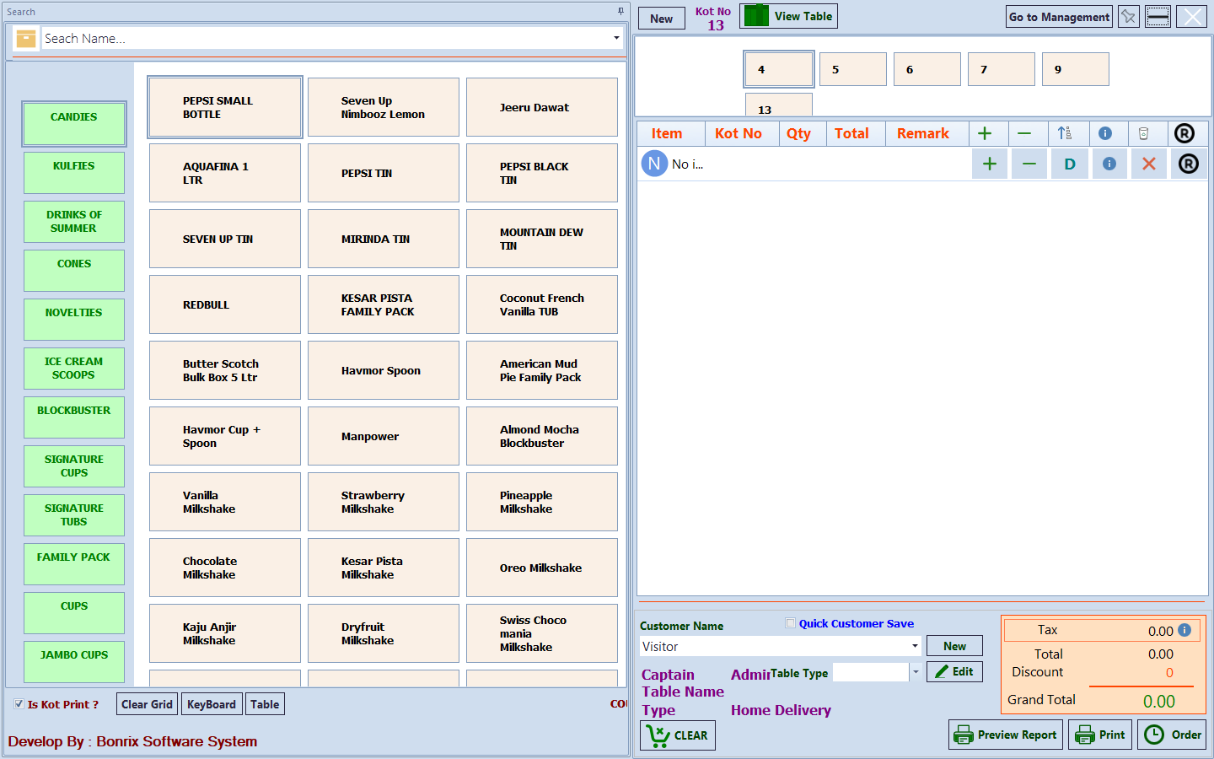

1. **Reports:**

**Sales Reports: Item wise, Category wise**

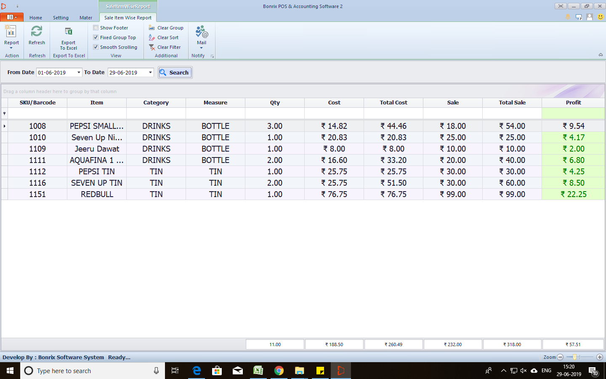

* **Ledger Report:**

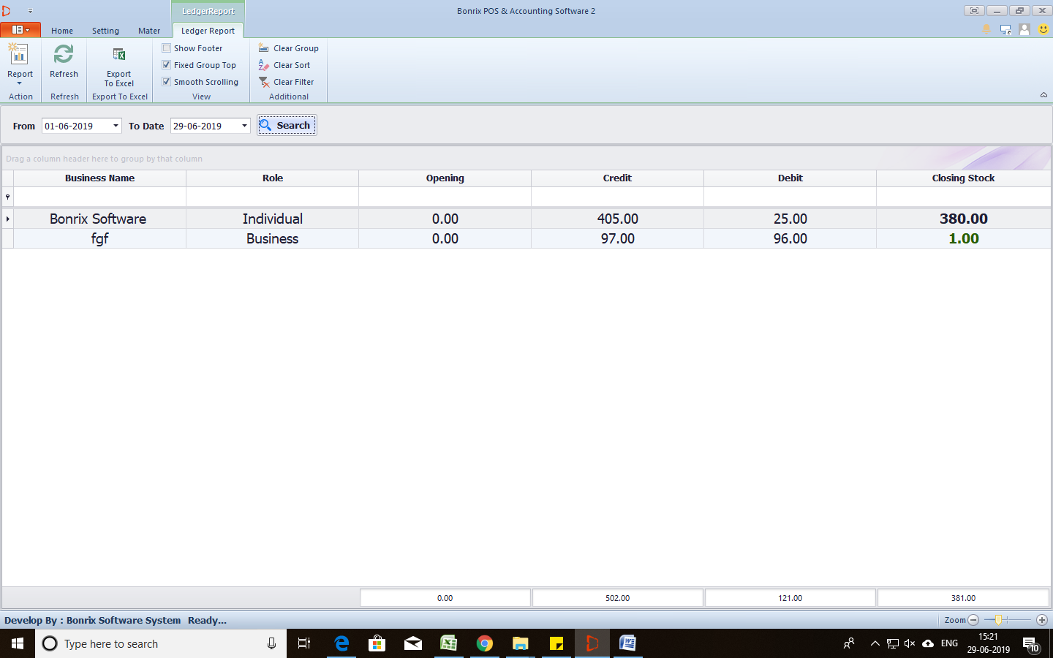

* **Table Master**

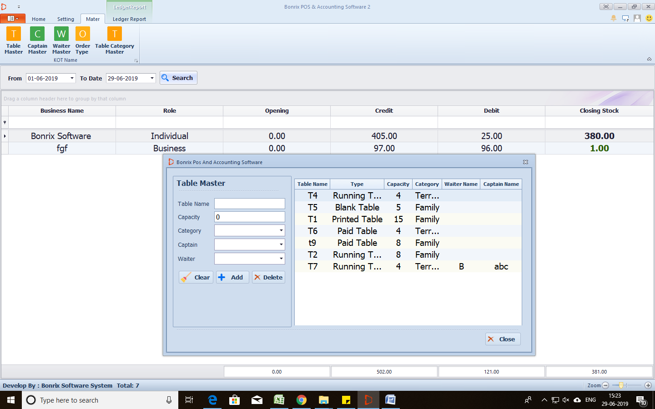

* **Inventory Management**
* 